Circular Singly Linked List | Insertion

Why Circular? In a singly linked list, for accessing any node of linked list, we start traversing from the first node. If we are at any node in the middle of the list, then it is not possible to access nodes that precede the given node. This problem can be solved by slightly altering the structure of singly linked list. In a singly linked list, next part (pointer to next node) is NULL, if we utilize this link to point to the first node then we can reach preceding nodes. Refer this for more advantages of circular linked lists.
The structure thus formed is circular singly linked list look like this:
In this post, implementation and insertion of a node in a Circular Linked List using singly linked list are explained.
Implementation
To implement a circular singly linked list, we take an external pointer that points to the last node of the list. If we have a pointer last pointing to the last node, then last -> next will point to the first node.
The ponter last points to node Z and last -> next points to node P.

Why have we taken a pointer that points to the last node instead of first node ?
For insertion of node in the beginning we need traverse the whole list. Also, for insertion and the end, the whole list has to be traversed. If instead of start pointer we take a pointer to the last node then in both the cases there won’t be any need to traverse the whole list. So insertion in the begging or at the end takes constant time irrespective of the length of the list.
Insertion
A node can be added in three ways:
- Insertion in an empty list
- Insertion at the beginning of the list
- Insertion at the end of the list
- Insertion in between the nodes

Insertion in an empty List
Initially when the list is empty, last pointer will be NULL.
After inserting a node T,
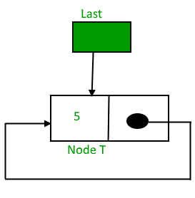
After insertion, T is the last node so pointer last points to node T. And Node T is first and last node, so T is pointing to itself.

